Title: **Sealing Circuit** Job: 6

Course: Introduction to Automation Unit: Introduction of PLC CLO: 1, 4

Name ____________________________ Station _______ Date ______________

**Objectives**

1. Student shall reinforce the purpose for a sealing control circuit.
2. Student shall solidify the knowledge for an “OR” circuit.
3. Student shall discover the use of registers as both outputs and inputs.

**Assessment**

Students shall demonstrate a comprehension of the objectives listed above by scoring a minimum of 75% on this shop job. Grading shall be based on the Manual Motor Controls rubric.

**Instructions**

Program the ladder logic shown below. The input I:0/5 is the upper normally open pushbutton (PB2) and the output O:0/0 is the green pilot light. Note that the output register is also being used as an input. One of the many benefits of a PLC is the fact that one piece of data, in this case an output register, can be used in many different locations (i.e. rungs) in multiple forms (inputs, outputs, etc.). This diverges from manual motor controls where if an input only exists once in the real world, it could only be drawn once in a wiring schematic. As just stated, this principle does not apply to PLCs. Also note that rung numbering starts at zero (0000) and sub-rungs, where input O:0/0 resides, is not numbered. This also is different from manual motor control schematics. Verify and download the program.

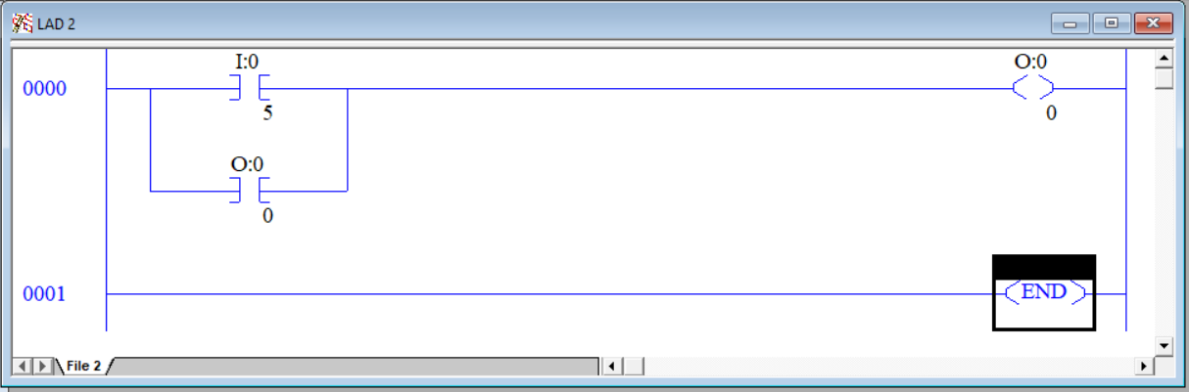

1. After downloading the program but before pressing PB2, complete row *Step 1* in the following truth table.

|  |  |  |  |  |
| --- | --- | --- | --- | --- |
| Step | PB2 | I/5 | O/0 | Green Light |
| 1 | 0 |  |  |  |
| 2 | 1 |  |  |  |
| 3 | 0 |  |  |  |

1. Press and hold PB2, complete row Step 2 in the above truth table.
2. Release PB2 and complete row Step 3 in the above truth table.
3. Explain why the output stays energized and the pilot light stays lit even though the pushbutton is no longer depressed.

__________________________________________________________________

1. This circuit has an inherent problem. What is the problem?

__________________________________________________________________

1. There is a way to improve this circuit to be able to de-energize the output and pilot light. How can this be done? Draw your solution below.

|  |  |  |  |  |  |  |  |  |
| --- | --- | --- | --- | --- | --- | --- | --- | --- |
|  |  |  |  |  |  |  |  |  |
|  |  |  |  |  |  |  |  |  |
|  |  |  |  |  |  |  |  |  |
|  |  |  |  |  |  |  |  |  |
|  |  |  |  |  |  |  |  |  |
|  |  |  |  |  |  |  |  |  |
|  |  |  |  |  |  |  |  |  |

1. Have the instructor review the revised program. Instructor Initials _________
2. After discussing the design and gaining approval, download and test the new program.